# Results of Characterization of Mating Switcher

## Proof of existence ofcomposite parts

In the early stage of the project, we construct two composite parts:BBa_K2407306 (we called PVUVC), BBa_K2407307(we called PVRVC).At the end of our project, we also construct one composite part called TVRVC. They are integrated into the chromosomes of Saccharomyces cerevisiae by transformation. We use colony PCR to proof the existence of these three parts in our strain.The result is showed as below.

琼脂糖凝胶电泳图。（PVUVC PURVC TVRVC，每个part3个）

Fig.XX.PCR of PVUVC, PURVC and TVRVC.

The PCR’s results confirmed that the target genes were ligated into chromosome correctly.

## Result of Mating

After we got the strain that introduced the red fluorescent protein gene, we let it mate with another mating type haploid yeast, which had plasmid with vika gene. The result isshowd as follows:

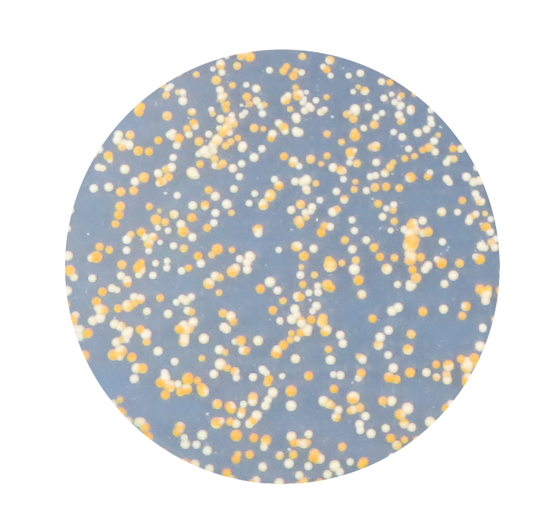

Fig.XX.bacteria after matingon the Sc-His plate.

There are 377 yellow colonies and 365 white colonies in the field of view,

The yellow colony in the figure is mating successfully. After the induction of galactose, vika enzymes was expressed, and red fluorescent protein gene and terminator was delete so that β-carotene expresses.As can be seen from the figure above, the reorganization efficiency is high, which reaches 50.8 percent.This proves that our Mating switcher is fast and efficient.

## Verification of RFP in the TVRVC

The main characteration method of verification of RFP in the TVRVC applied by us is observing the expression of fluorescent protein under the fluorescence microscope. By this way, it will be much more intuitive so that we can directly get the results. We took pictures under different vision and the results are as follows.

（插六幅图）Fig.1.2.3 Microscope image of yeast

cultured with YPD with no ***yEmRFP*** gene transformed.

Fig.4.5.6 Microscope image of yeast

cultured with YPD with no ***yEmRFP*** gene transformed.

From these images we can clearly see the expression of ***yEmRFP***. These images undoubtedly verify the ***yEmRFP*** gene has been transformed succeedly.

Meantime, We cultured the transformed yeast in several 5mL liquid YPD at 30℃ and 220 rpm for 12 hours ( Take three samples at a time). We used one sample for centrifugation to precipitate the bacterial and the remaining two remained unchanged. The difference is the fluorescence value we need, then we calculated the value of average them. The excitation wavelength is set at 540nm and the emission wavelength is set at 635nm. Hereafters, we measured the bacterial concentration at OD600. At last, we divided the fluorescence value by OD600 to normalize the value and the result data are as follows.

(一幅图)Fig.7 Normalized fluorescence value was calculated by dividing fluorescent value by cell concentration(OD600). Error bars represent standard deviation from 3 repeats.

These values represent the mean normalised fluorescence value from 3 technical repeats and error bars represent standard deviation